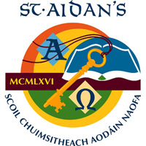

**PRINCIPAL**

St Aidan’s Comprehensive School

Cootehill Co Cavan

Category XV

The Board of Management of St Aidan’s Comprehensive School invites applications from suitably qualified persons for the post of Principal to take effect from 01 September 2023. St Aidan’s is a Comprehensive, co-educational, multi-denominational second level school with an enrolment of 589 on 30 September 2022.

On application candidates must have a

* Recognised post-primary teaching qualification
* Minimum of 5 years’ satisfactory teaching experience
* Registration in accordance with Section 30 of the Teaching Council Act 2001

Application forms and full details may be obtained by applying in writing to The Chairperson of the Board of Management, St Aidan’s Comprehensive School Cootehill Co Cavan

or from [www.staidans.ie](http://www.staidans.ie) or by email from office@staidans.ie.

Completed application forms should be submitted **in hard copy only** no later than 4.00 pm on 20th June 2023 to the Chairperson of the Board of Management, St Aidan’s Comprehensive School Cootehill Co Cavan.

Short listing may apply.

Canvassing by or on behalf of the candidate will automatically disqualify.

Late applications will not be accepted.